Report on Swachhta Hi Seva campaign in Puducherry
 | Name of the officer | Rita Khanna
 | Designation | Director/Scientist ‘F’
 | State Assigned | Puducherry
 | Activities to be carried out  - Green Pledge  - Cleaning of Parks/ Rivers/ Beaches/Lakes  - Taking out “Swachhta Procession” NSS/ NCC volunteers  - Undertaking plantation activities  - Cleaning drive in the office premises, National Park/ Protected Areas | Activities undertaken:  - Green Pledge  - Cleaning of Lake  - Cleaning of Market areas  - Plantation activities
Report in Brief
In pursuance of O.M no. 8-67/2016-EE (Vol. I). dated 25th September and 26th September 2017 on Swachhta Hi Seva- 15th September to 2nd October 2017, Swachh Bharat Mission, Swachhta Hi Seva campaign was organized by the Ministry of Environment, Forest and Climate Change in Puducherry on 28.9.2017 in consultation with Department of Science, Technology and Environment and the Forest and Wildlife Department of Puducherry.
- Green Pledge:
The event started with the Green Pledge taken up by a large gathering of Government staffs, officials and volunteers who gathered at the Oussudu Bird Sanctuary.
- Cleaning of Protected Areas / Lakes:
Cleanup Programme was organized in the Oussudu Bird Sanctuary. During the cleaning program, the staffs of the Forest Department, volunteers from NGOs and officials collected plastic and trash around the lake and disposed it to the Municipal Solid Waste Disposal Site.
- Cleaning of Market areas:
A Clean-up programme was organized in the Sanmugapuram Vegetable Market area along with the staffs and workers of the Oulgaret Municipality and Swatchada Corporation.
Another Clean-up programme was organized in the Lawspet Vegetable Market called as ‘Uzhavar Sandhai’ or ‘Farmers Market’ where farmers directly sell their produce like fruits and vegetables without any middle men. Staff and workers of the Oulgaret Municipality and Swatchada Corporation, Market Vendors and other volunteers actively participated in the cleaning drive.
- Plantation activities:
Plantation activities have been taken up along the banks of the Oussudu Lake. Saplings have been supplied by the State Forest Department.
The Event was concluded with thanks to all the participants, State Forest and Wildlife Department and Department of Science, Technology & Environment, Govt. of Puducherry.
Some of the photographs showing activities taken up during the campaign are attached.
Some photographs of Swachhta Hi Seva campaign in Puduchherry on 28 September 2017
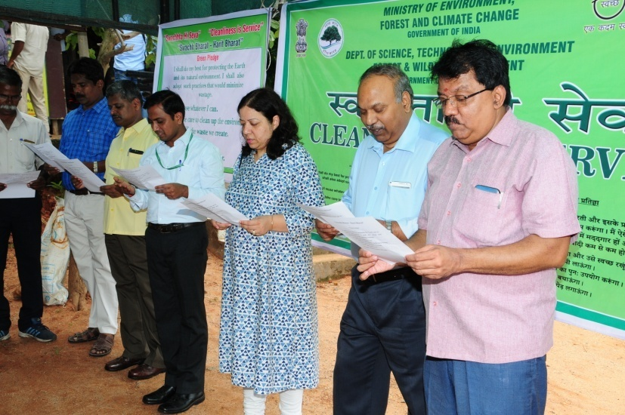 | 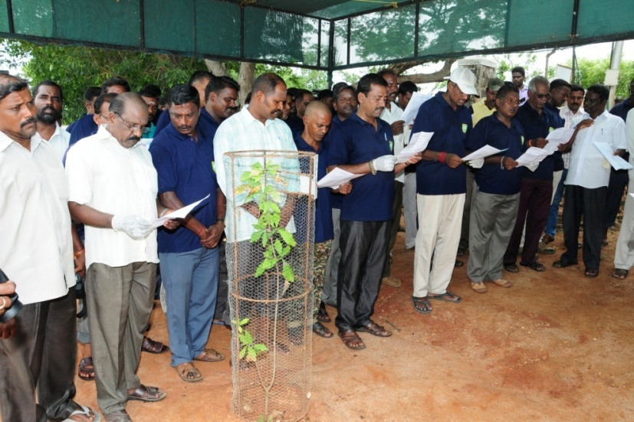
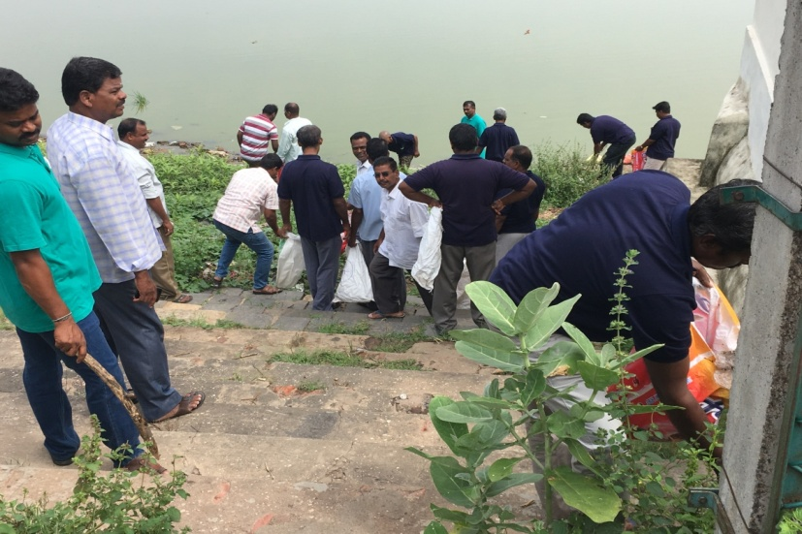 | 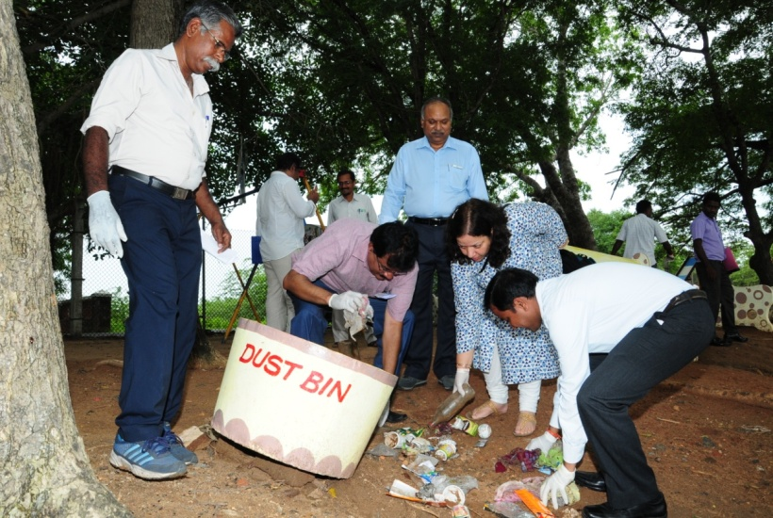
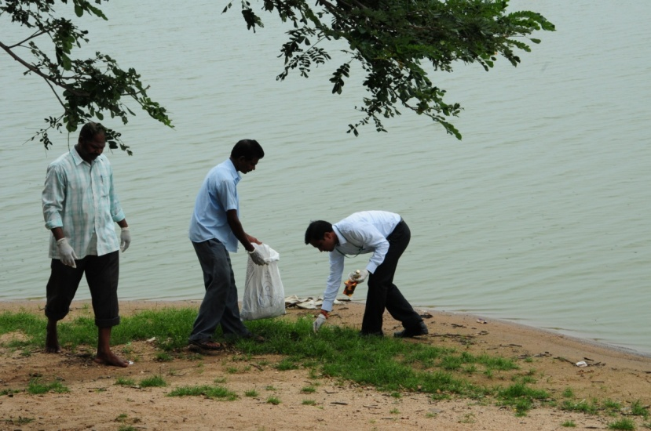 | 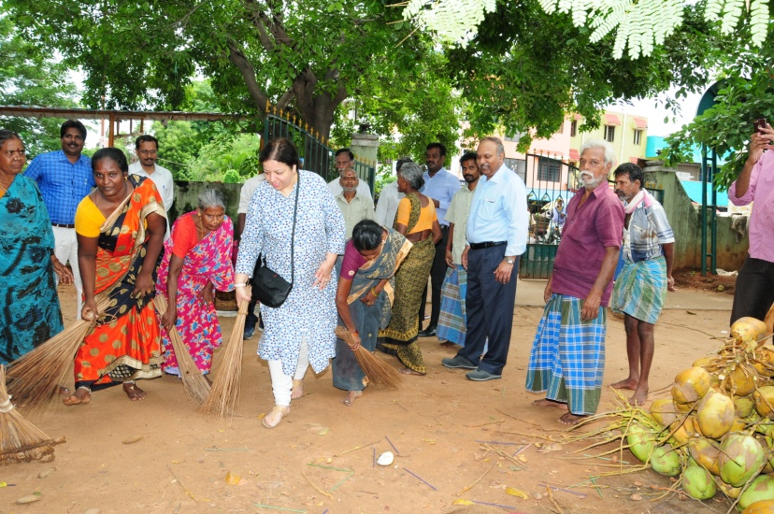
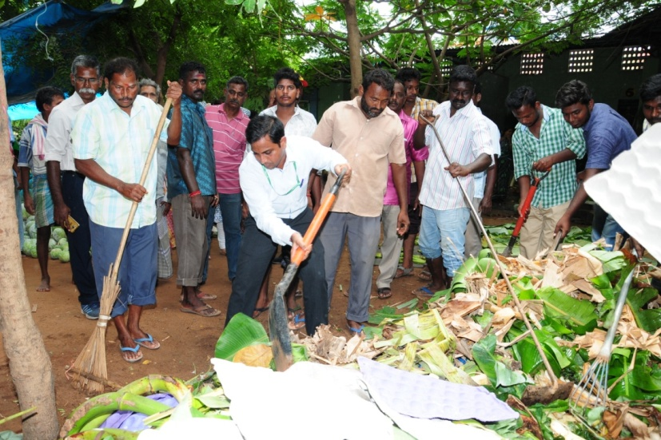 | 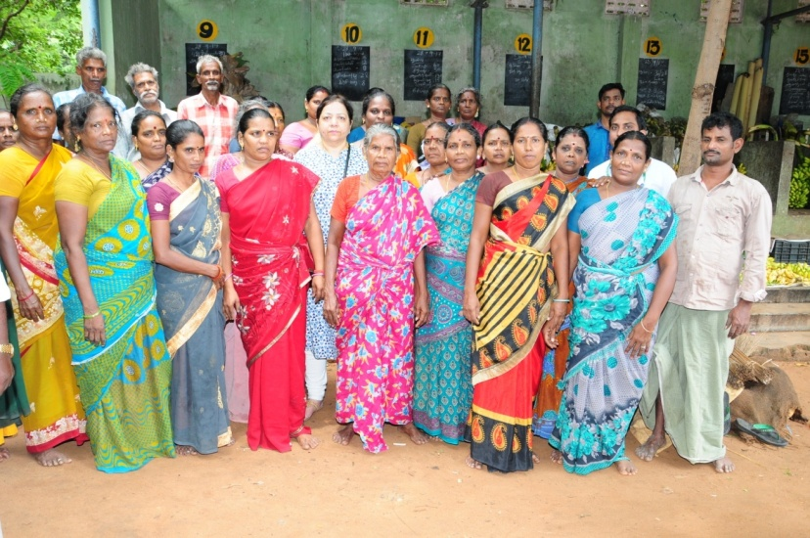
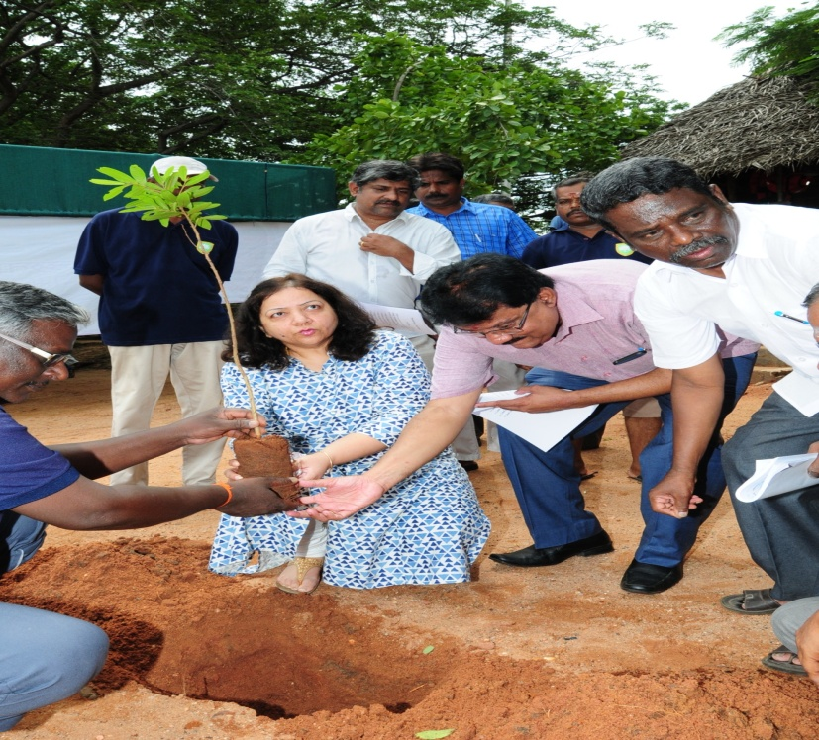 | 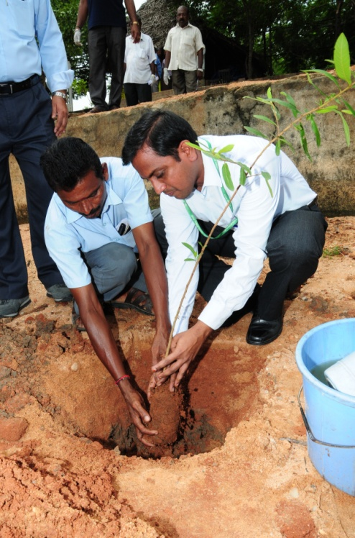
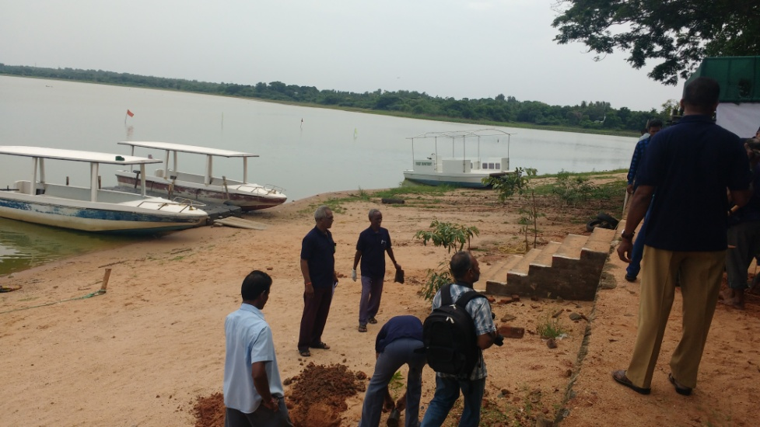 | 