Visit Report
1. | Name of Officer | Sh. Sanjay Pandey
2. | Designation | Chief Controller of Accounts
3. | State Assigned | Jharkhand
4. | Activities to be carried out | - Green Pledge  - Cleaning of Parks, Rivers, Beaches, Lakes  - Taking out “Swachhta Procession”  - Undertaking plantation activities  - Cleaning drive in the office premises, National Park/Protected areas
Report:
“Swachhta Hi Seva” campaign was conducted on 2nd October, 2017 at Institute of Forest Productivity (ICFRE Institute) Ranchi, Jharkhand in association with Regional Office, Ranchi. The campaign was initiated by State Nodal Officer (SNO), Sh Sanjay Pandey, Chief Controller of Accounts in the M/o Environment, Forest and Climate Change. The SNO briefed about the SWACHH BHARAT MISSION launched on 2nd October, 2014 by Hon’ble Prime Minister, the Ministry’s initiative ‘Prakriti Paryavaran aur Hum’ and other awareness campaigns including ‘Anti- cracker’. The ‘Swachhta Hi Seva’ is underway from 15th September- 2nd October 2017 and the role of the government is to create awareness about cleanliness among the citizen of India. He also mentioned how the Ministry has further improvised this campaign and named it ‘Swachh and Swasth Bharat (SSB)’. The areas of intervention/activities during the “Swachhta Hi Seva” were highlighted. All the participants took the Green Pledge to protect earth and its natural environment, reduce waste, conserve water and electricity, and plant more trees. Afterwards, cleanliness drive was conducted by the SNO, Director(IFP), all officers/staff of IFP and Regional Office. Further, plantation activity was carried out by officers/staff and children. Everyone pledged to create awareness and contribute to the so that the Swachh Bharat Mission becomes goal of all Indians. The need to develop synergy and network among different offices of the Ministry was emphasized.

Pictures regarding Activities:
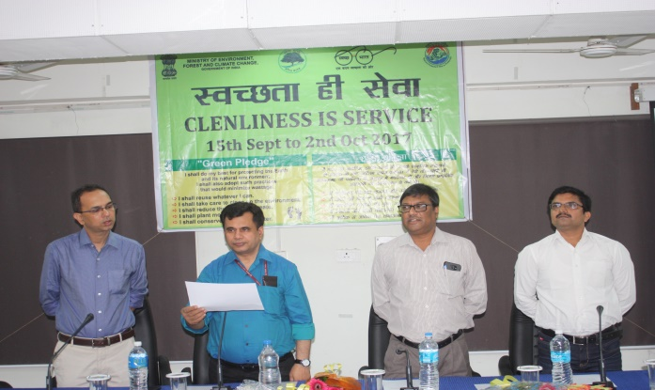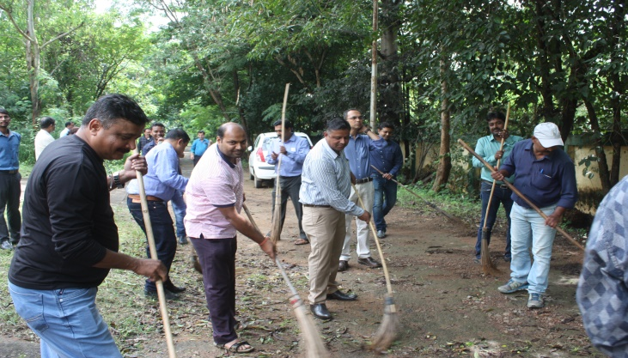
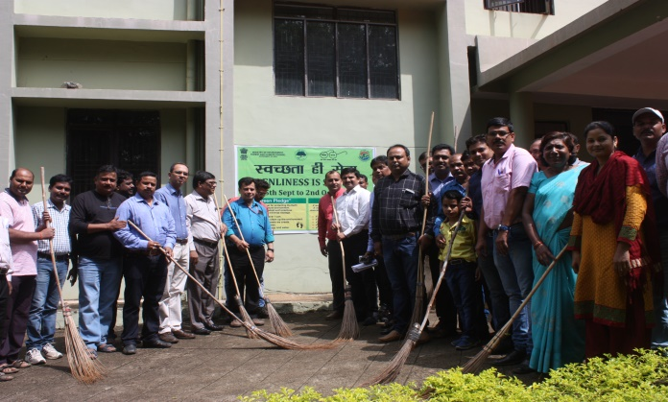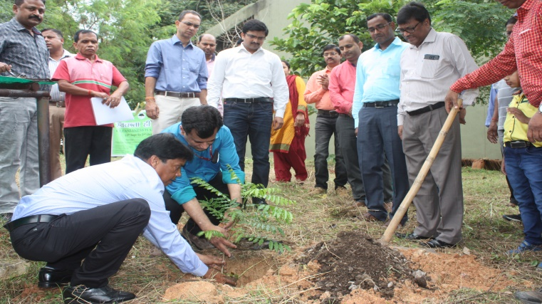
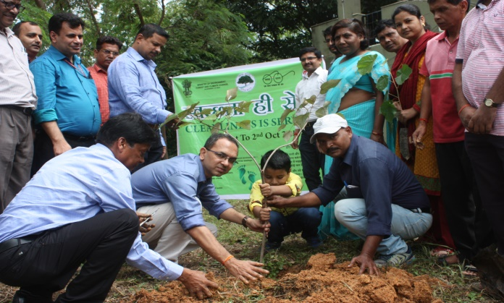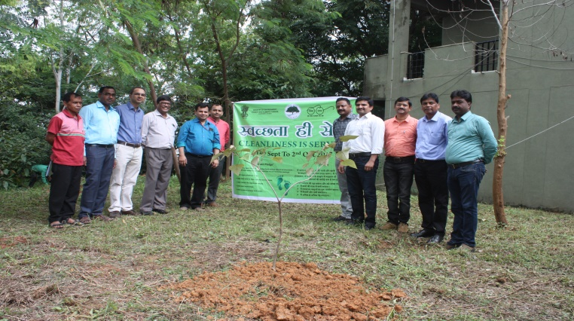
Feedback/Suggestions by Participants:
- Proper disposal of left over polybags of seedlings used during the plantation
- Accreditation to the institute for doing good work towards cleanliness. Ministry/ICFRE can benchmark institutes on cleanliness.
- Cleanliness and hygiene awareness among school children. The drive needs to be taken up in school/colleges.
- Mechanism for monitoring of compensatory plantation work around development project like canal, road, railways, etc.
- Involvement of cleanliness component as part of different research/extension/ development projects.
- Restriction/ban on pan/gutka in the Government premises and on advertisement in electronic and print media.

